**Group 52:- Members**

**Dhairya Mihir Shah - 2024AB05218**

**Rahul Arvind Patil - 2024ab05208**

**Nidhi Mittal -**

**Task 1: Problem Formulation**

### **Business Problem**

Banks face significant revenue loss when customers close their accounts (customer churn). Retaining existing customers is generally more cost-effective than acquiring new ones. The problem is to **predict which customers are most likely to churn**, so the bank can take proactive retention actions such as personalized offers, improved customer service, or targeted communication campaigns.

### **Key Business Objectives**

**Reduce customer churn rate** by early identification of at-risk customers.

**Increase customer lifetime value (CLV)** through retention strategies.

**Optimize marketing costs** by targeting interventions only to high-risk segments.

**Enhance customer satisfaction and loyalty** by identifying dissatisfaction patterns.

### **Key Data Sources and Attributes**

The dataset (Customer Bank Churn dataset) typically contains:

**Customer Demographics**: Age, Gender, Geography.

**Banking Details**: Tenure, Balance, Number of products, Credit score, Has creditcard, Is active member.

**Account Activity**: Estimated salary, Transaction history.

**Target Variable**: Exited (Yes/No).

### **Expected Outputs from the Pipeline**

**Clean datasets** for exploratory data analysis (EDA), removing duplicates, handling missing values, and normalizing numeric attributes.

**Transformed features** suitable for machine learning models (e.g., categorical encoding, feature scaling, interaction variables).

**A deployable predictive model** to classify customers as *churn risk* vs *non-churn*.

**Business insights dashboard** highlighting churn drivers (e.g., low tenure, inactive accounts).

### **Measurable Evaluation Metrics**

* **Accuracy**: Overall correctness of predictions.
* **Precision & Recall**: To ensure true churners are correctly identified while minimizing false positives.
* **F1-Score**: Balances precision and recall, useful for imbalanced datasets.
* **Business KPI**: Reduction in churn rate post-deployment (tracked quarterly).

**Note :-** All results are stored in / DMML_Machine_Learning_Pipeline/results folder

GIHUB LINK FOR PROJECT :- https://github.com/dhairyas87/dmml-bank-churn-pipeline

## **Task 2: Data Ingestion**

Downloading datasets from Kaggle and Microsoft Links.

Here the retry mechanism has been added along with interval of 60 Seconds for data ingestion in method call.

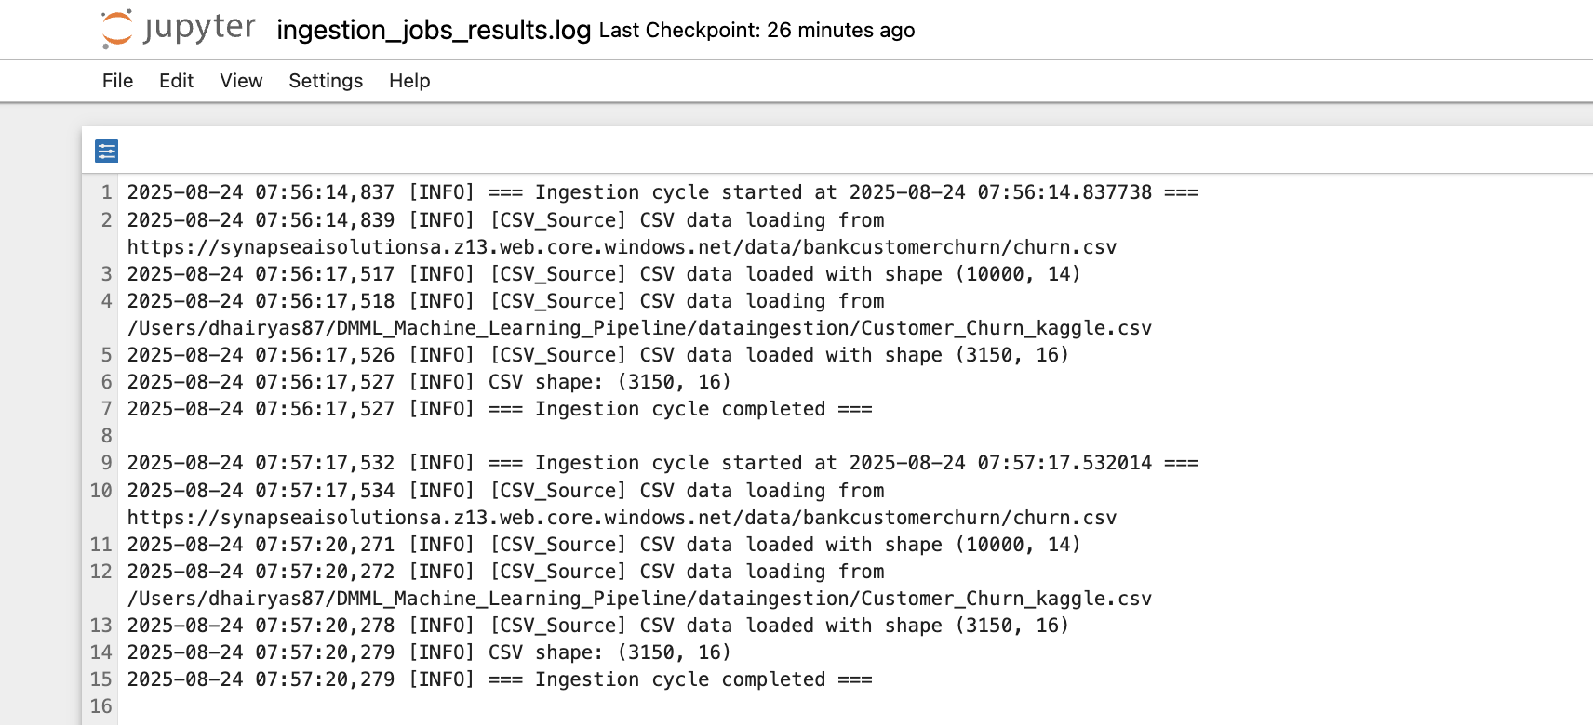

However, From pipeline perspective we have kept an retry mechanism only.

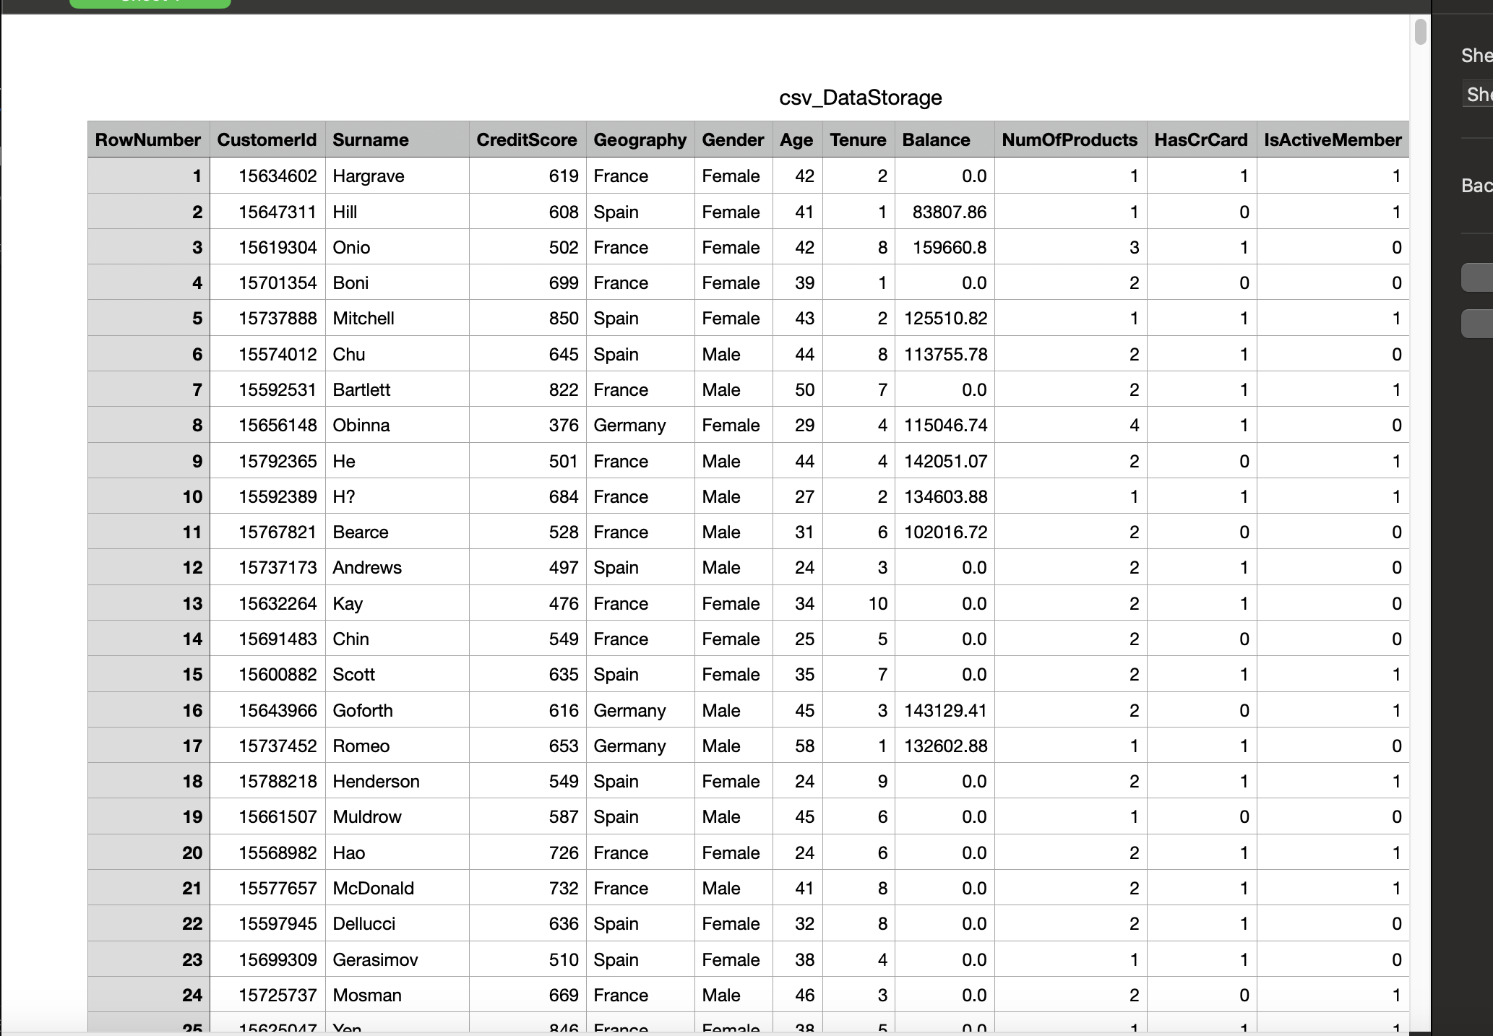

**Task 3: Data Storage**

Results: DMML_Machine_Learning_Pipeline/results/store_data/

Folder structure partition has been done using the partition by year/month/day to keep the data ingestions and storage everyday and seperate.

The storage is currently done in local folder structure as the other options available for the data machine learning pipeline had costs.

Folder structure documented and segregated by year/mm/dd

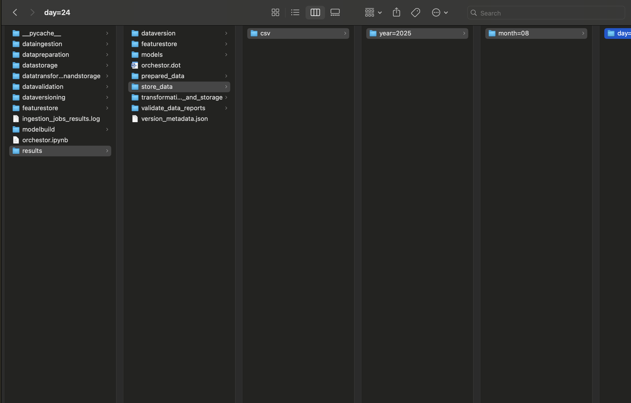

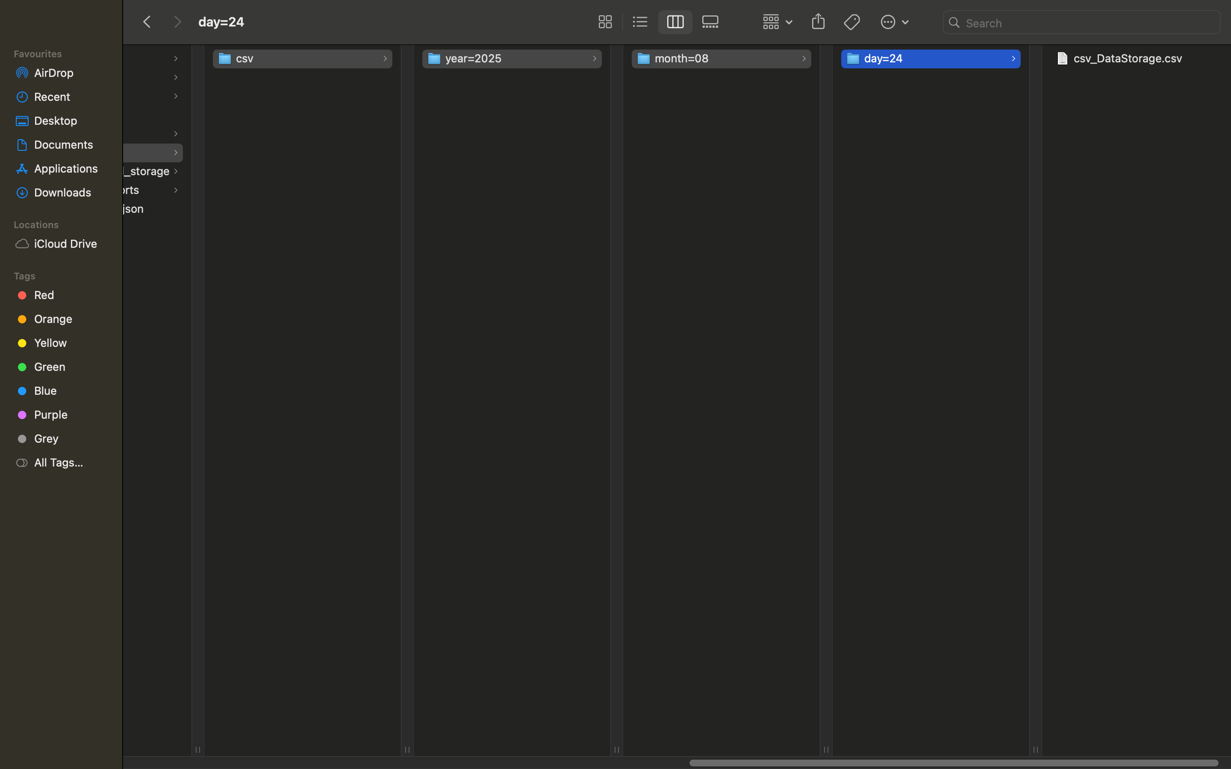

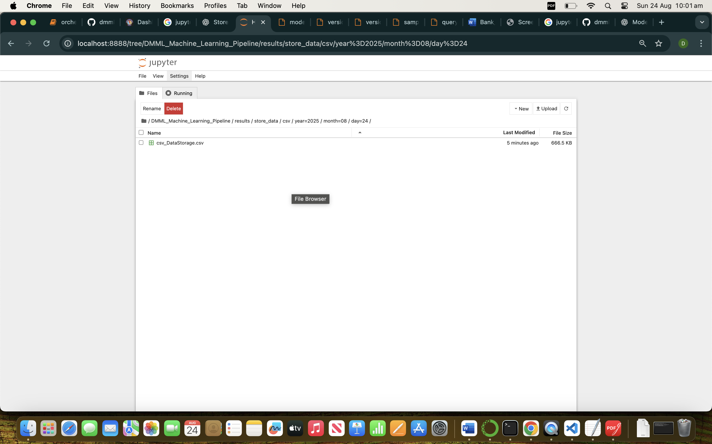

**TASK 4: Data Validation**

Results :- [/DMML_Machine_Learning_Pipeline/results/validate_data_reports/](http://localhost:8888/tree/DMML_Machine_Learning_Pipeline/results/validate_data_reports)

Data Validation & Quality report

Data validation report containing Missing values, Duplicate, Data Type and the Numeric Summary.

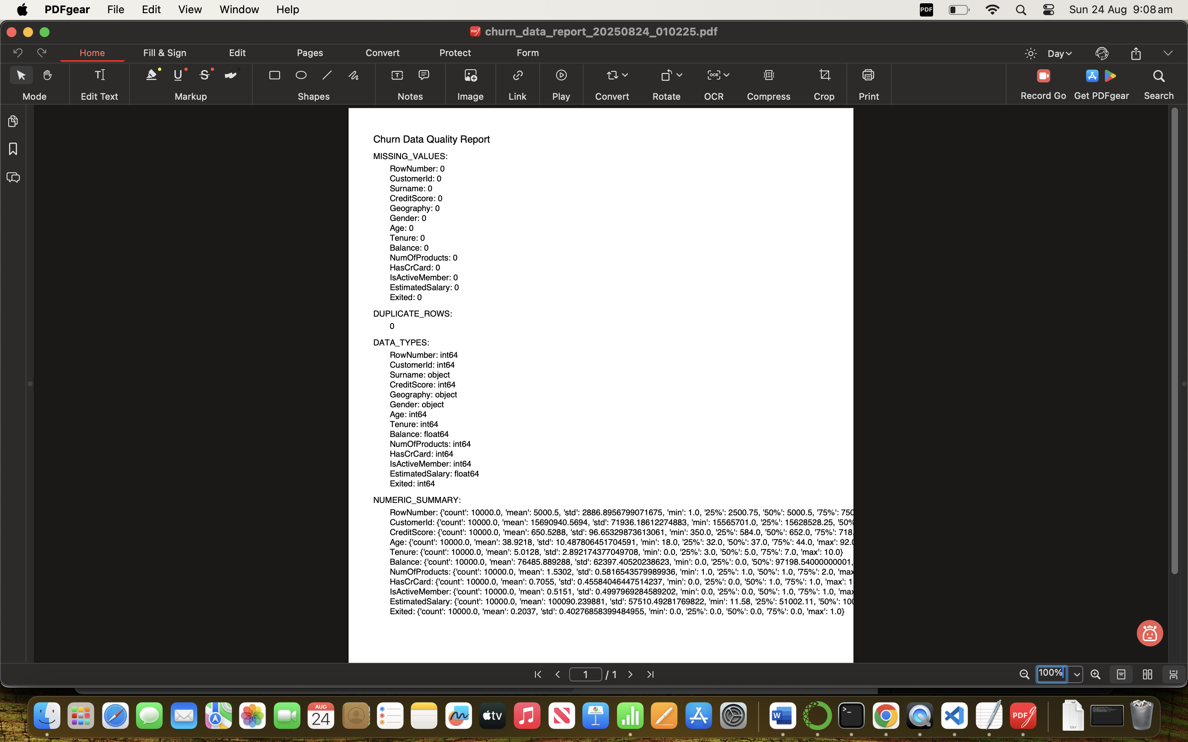

**Task 5: Data preparation**

Results - DMML_Machine_Learning_Pipeline/results/prepared_data/

Handling Missing Values , handling outliers , encoding variables and Showing graphs of the histogram plots.

* **Distribution of Features:**
  + Most customers are concentrated in middle-age brackets.
  + Balance and salary distributions are skewed, requiring scaling.
  + Gender and geography show mild imbalance.
* **Churn Patterns:**
  + Customers with higher balances but fewer products tend to churn.
  + Long-tenure customers are less likely to churn.
  + Geography (certain regions) show higher churn.

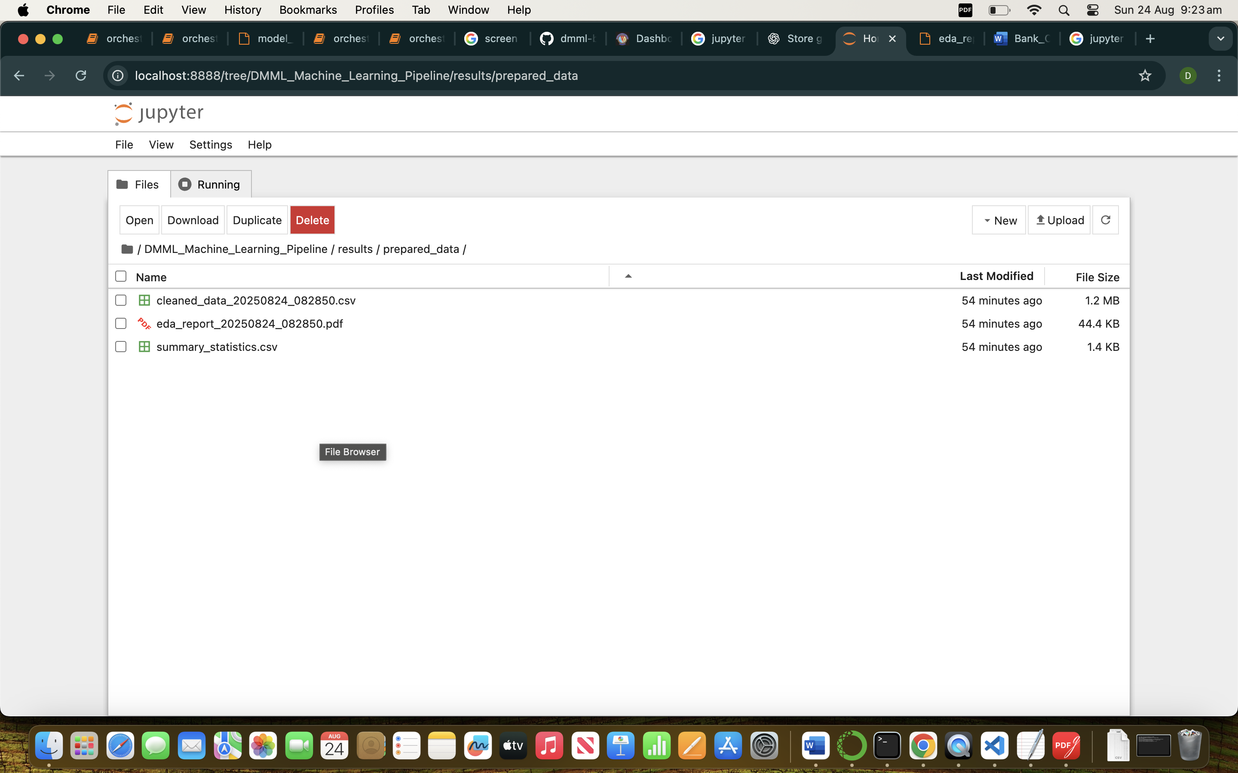

Summary Characteristics:-

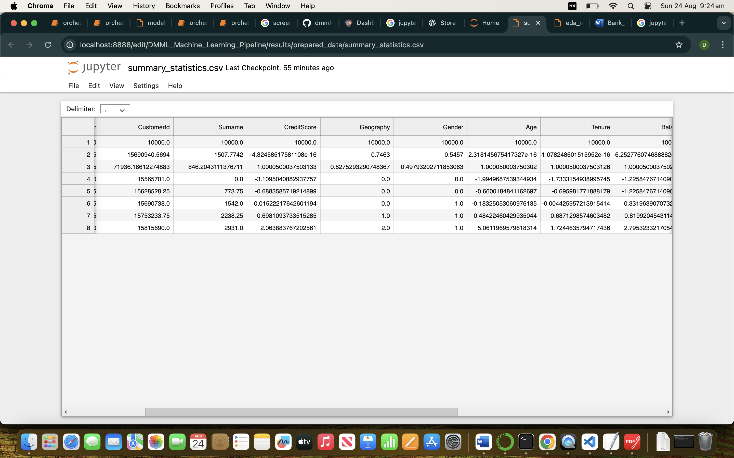

Exploratory data analysis :- EDA PDF containing all histograrm plots, Co-relation heatmap etc.

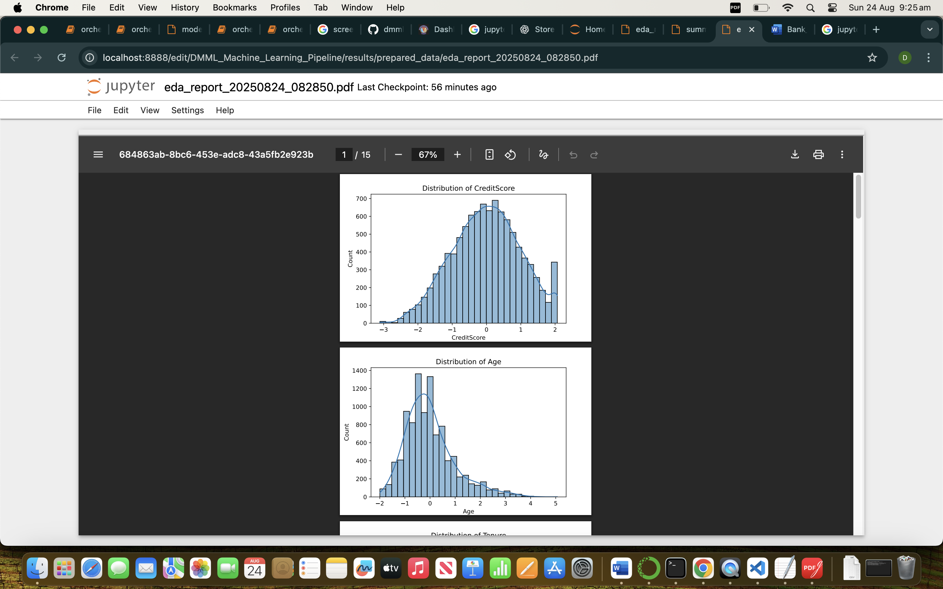

## **TASK 6 :- Transformation & Storage**

Results :- DMML_Machine_Learning_Pipeline/results/transformation_and_storage

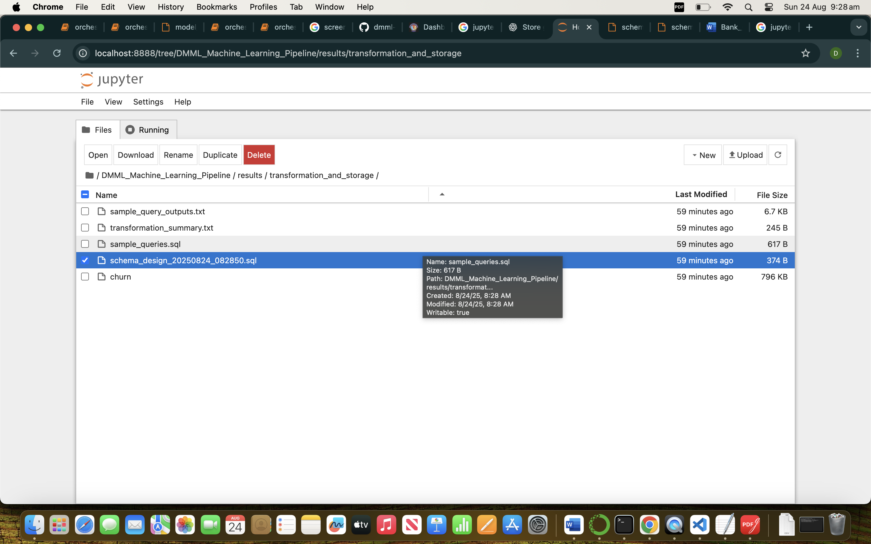

=== Transformation Logic Applied ===

- Created AgeGroup from Age (bins: <25, 25-40, 40-60, >60).

- Created BalanceSalaryRatio = Balance / (EstimatedSalary + 1).

- Created CreditScoreBucket from CreditScore (Low <500, Medium 500-700, High >700).

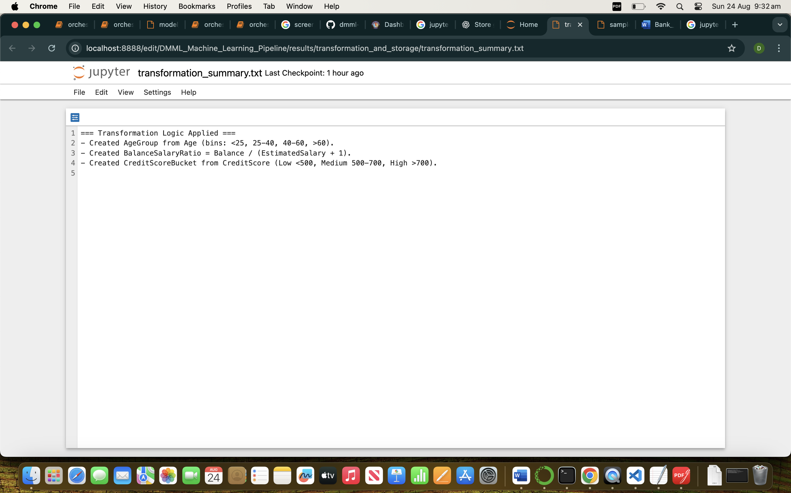

Schema Design for Transformed Churn.

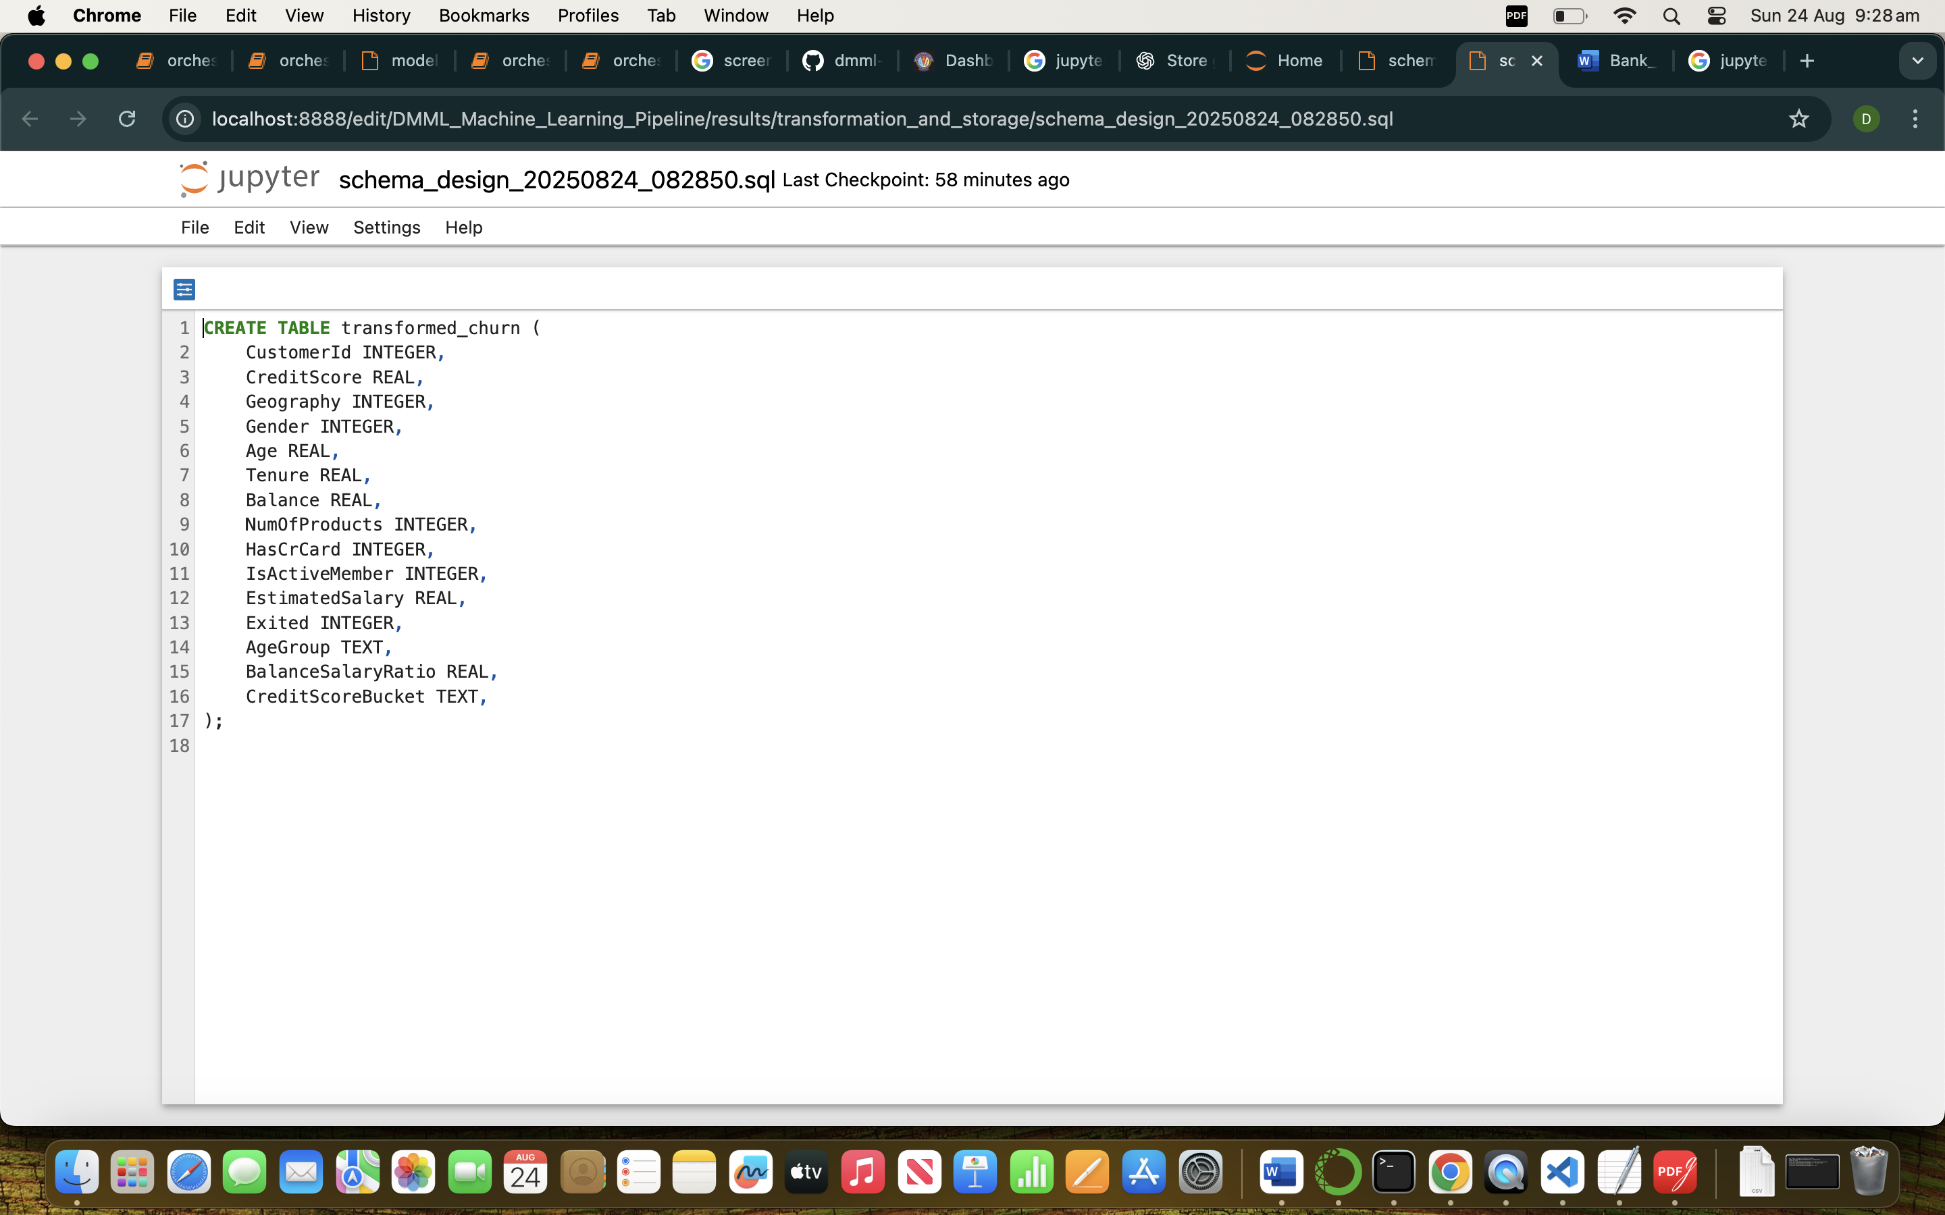

Sample Queries to derive transformed data.

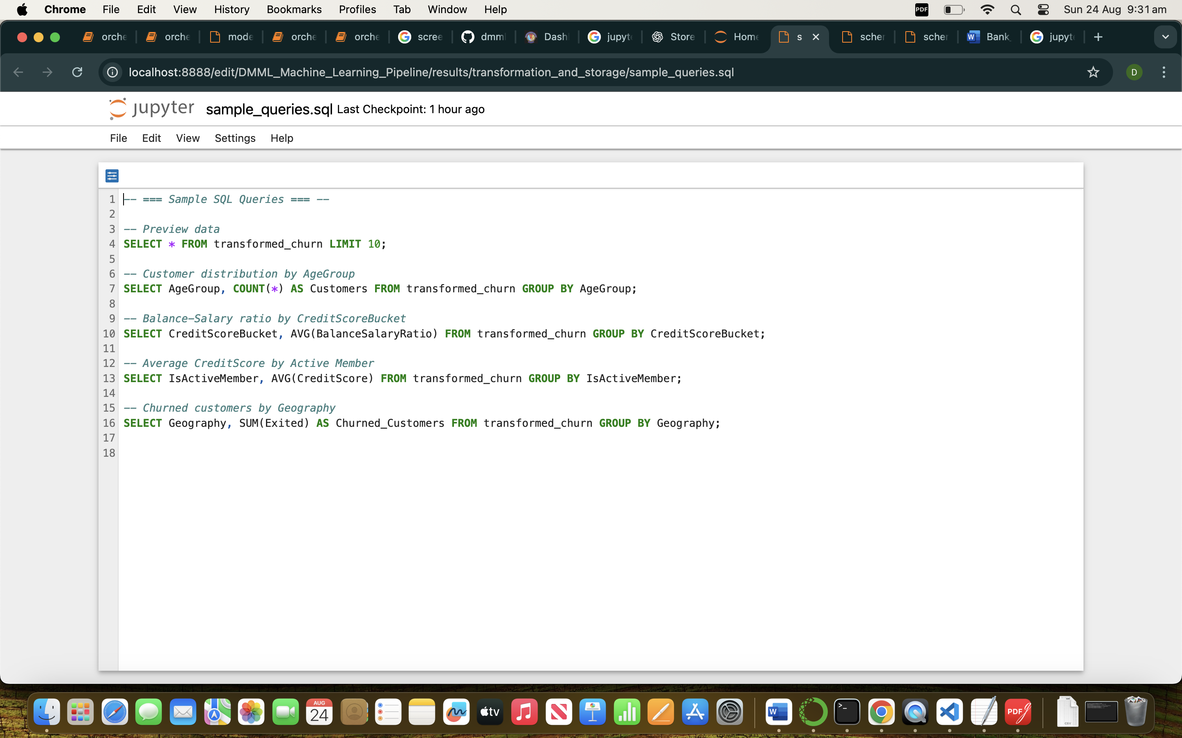

Sample Query Outputs:

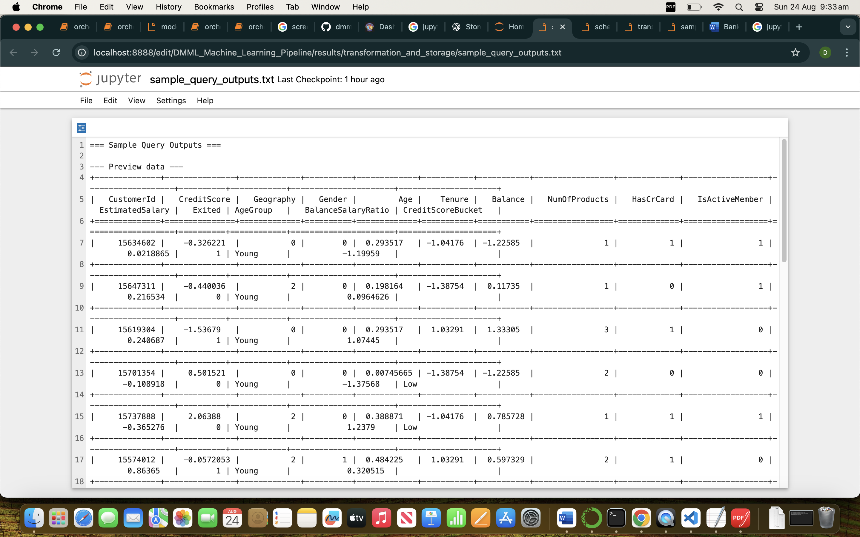

## **Task 7:- Feature Engineering / Feature Store**

Results :- DMML_Machine_Learning_Pipeline/results/featurestore

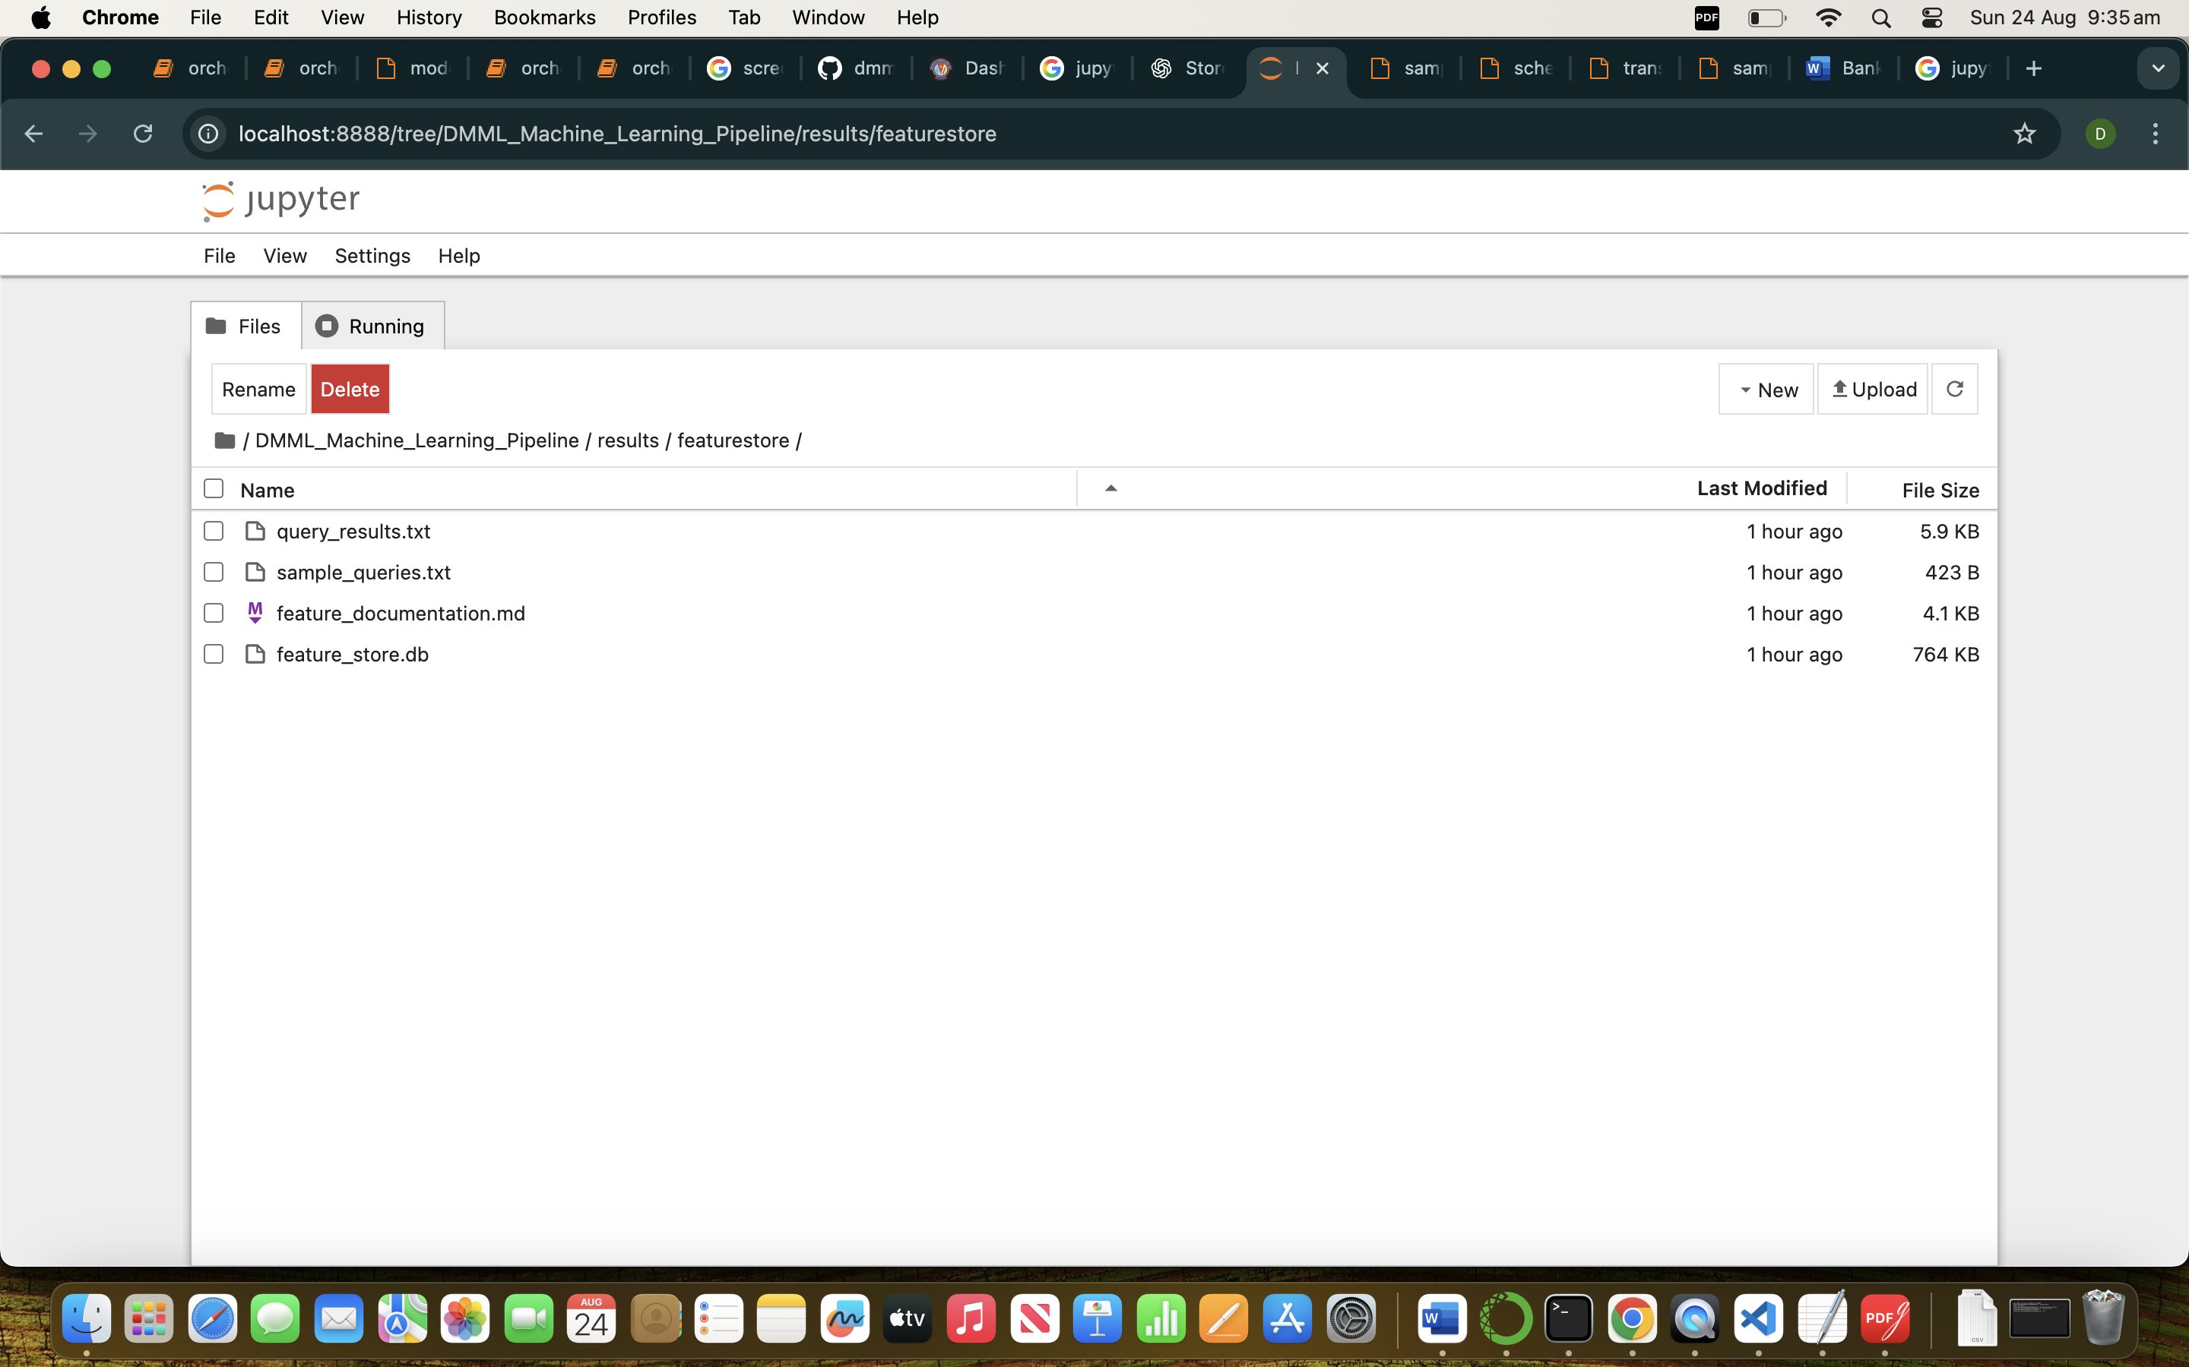

Feature Store Documentation Versioning and Description -

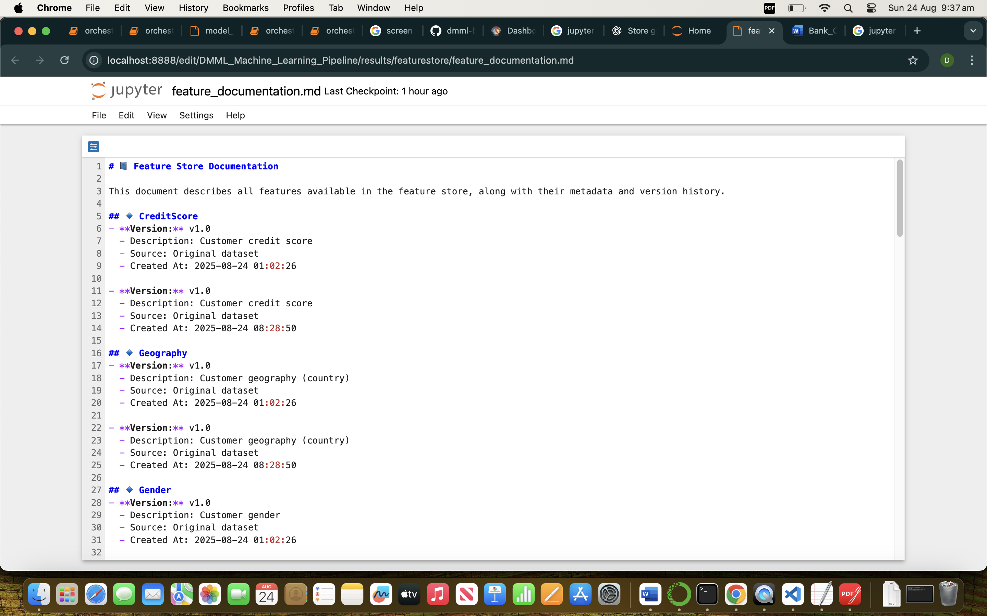

Feature Metadata:-

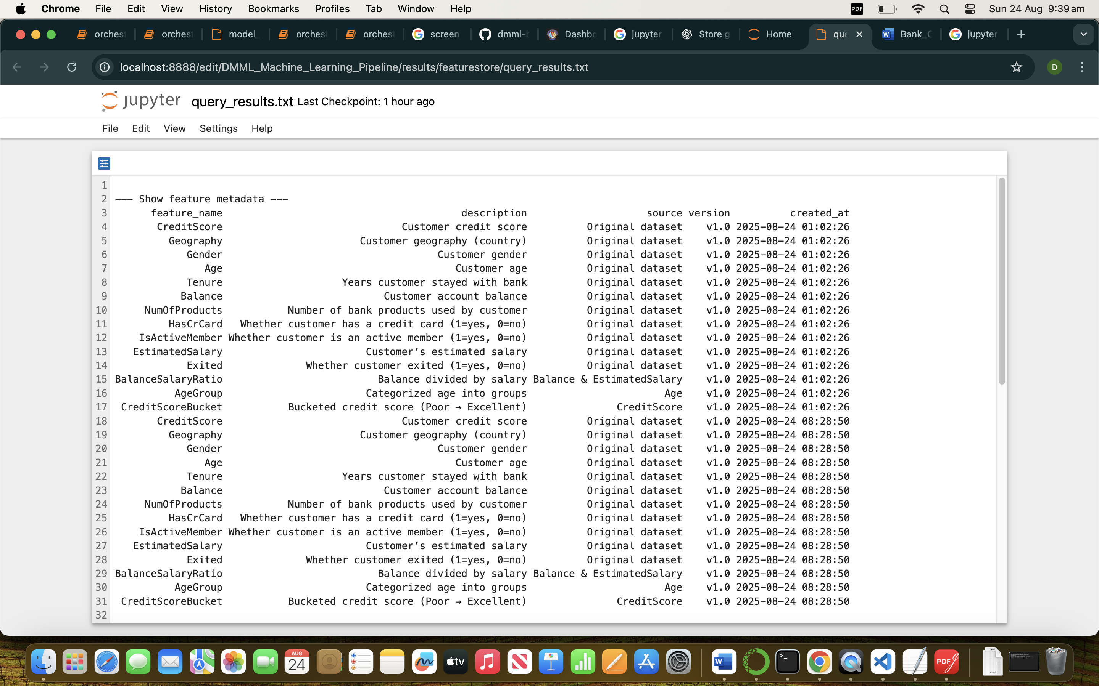

**Sample Queries:-**

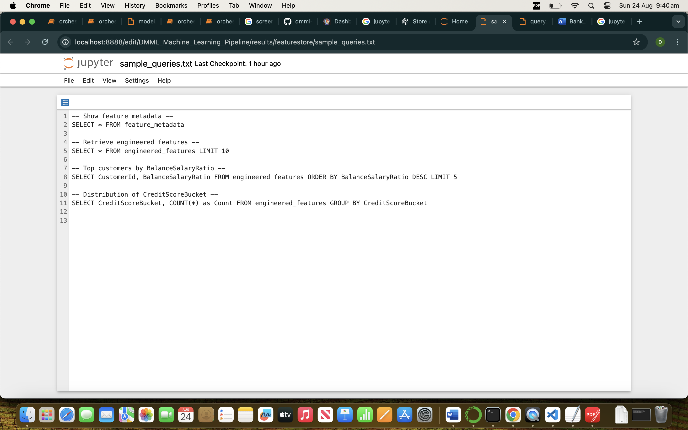

## **TASK 8 Data Versioning**

Results :- DMML_Machine_Learning_Pipeline/results/dataversion

Git Link:- <https://github.com/dhairyas87/dmml-bank-churn-pipeline/blob/main/results/version_metadata.json>

We have done data versioning using git and we have generated 1 version_metadata json file which would log and track all the changes related to transformed and raw data sets that has been there.

Ensures **reproducibility** and ability to restore changes

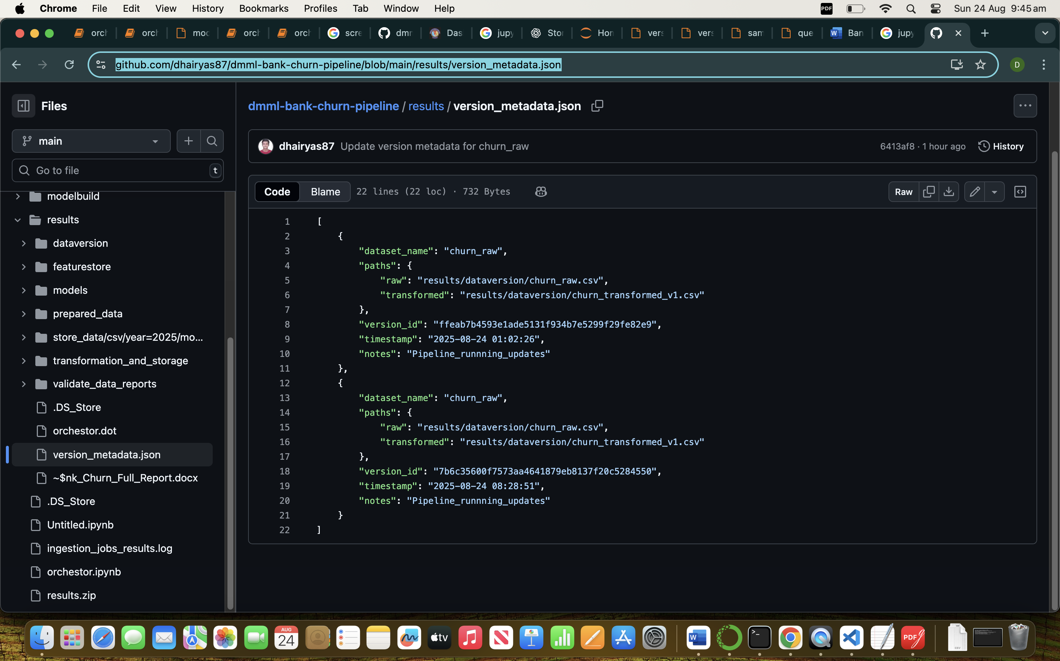

* **Raw Dataset, Transformed Dataset**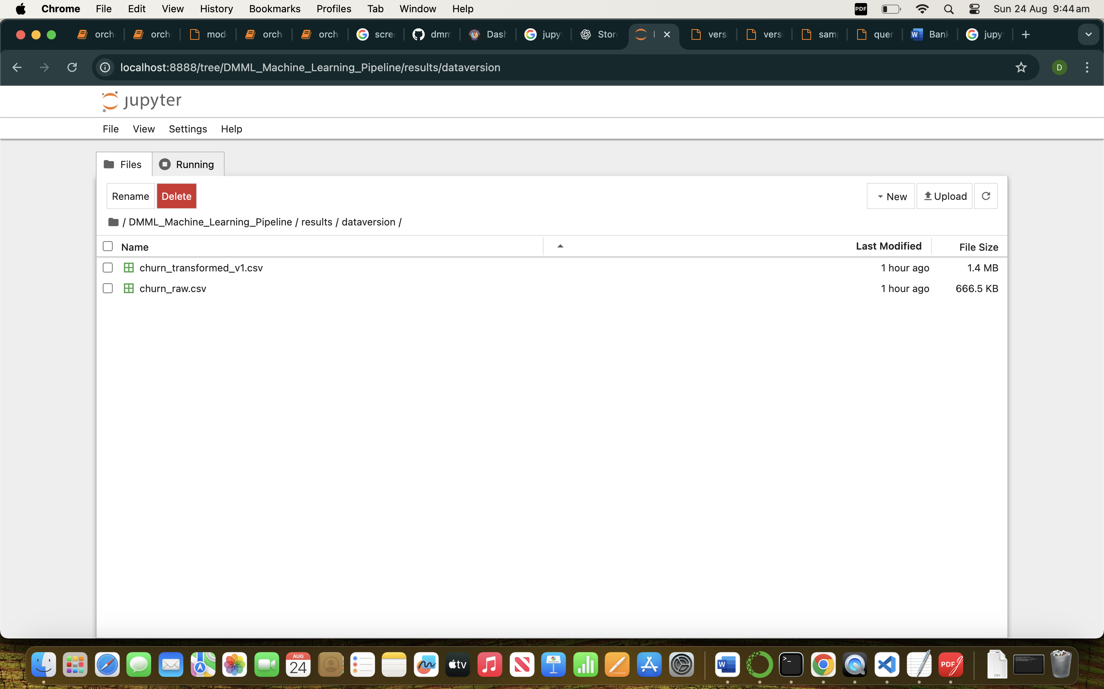

## **TASK 9: Model Training & Evaluation**

* Logistic Regression
* Random Forest
* SVM

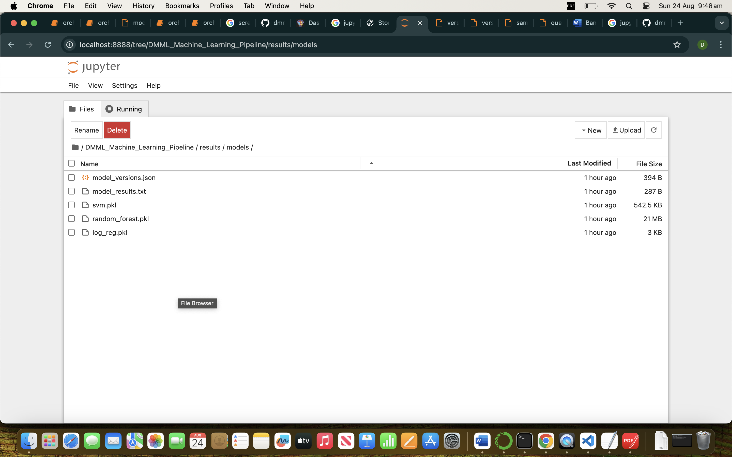

### **Evaluation Metrics:**

* Accuracy
* Precision
* Recall
* F1 Score

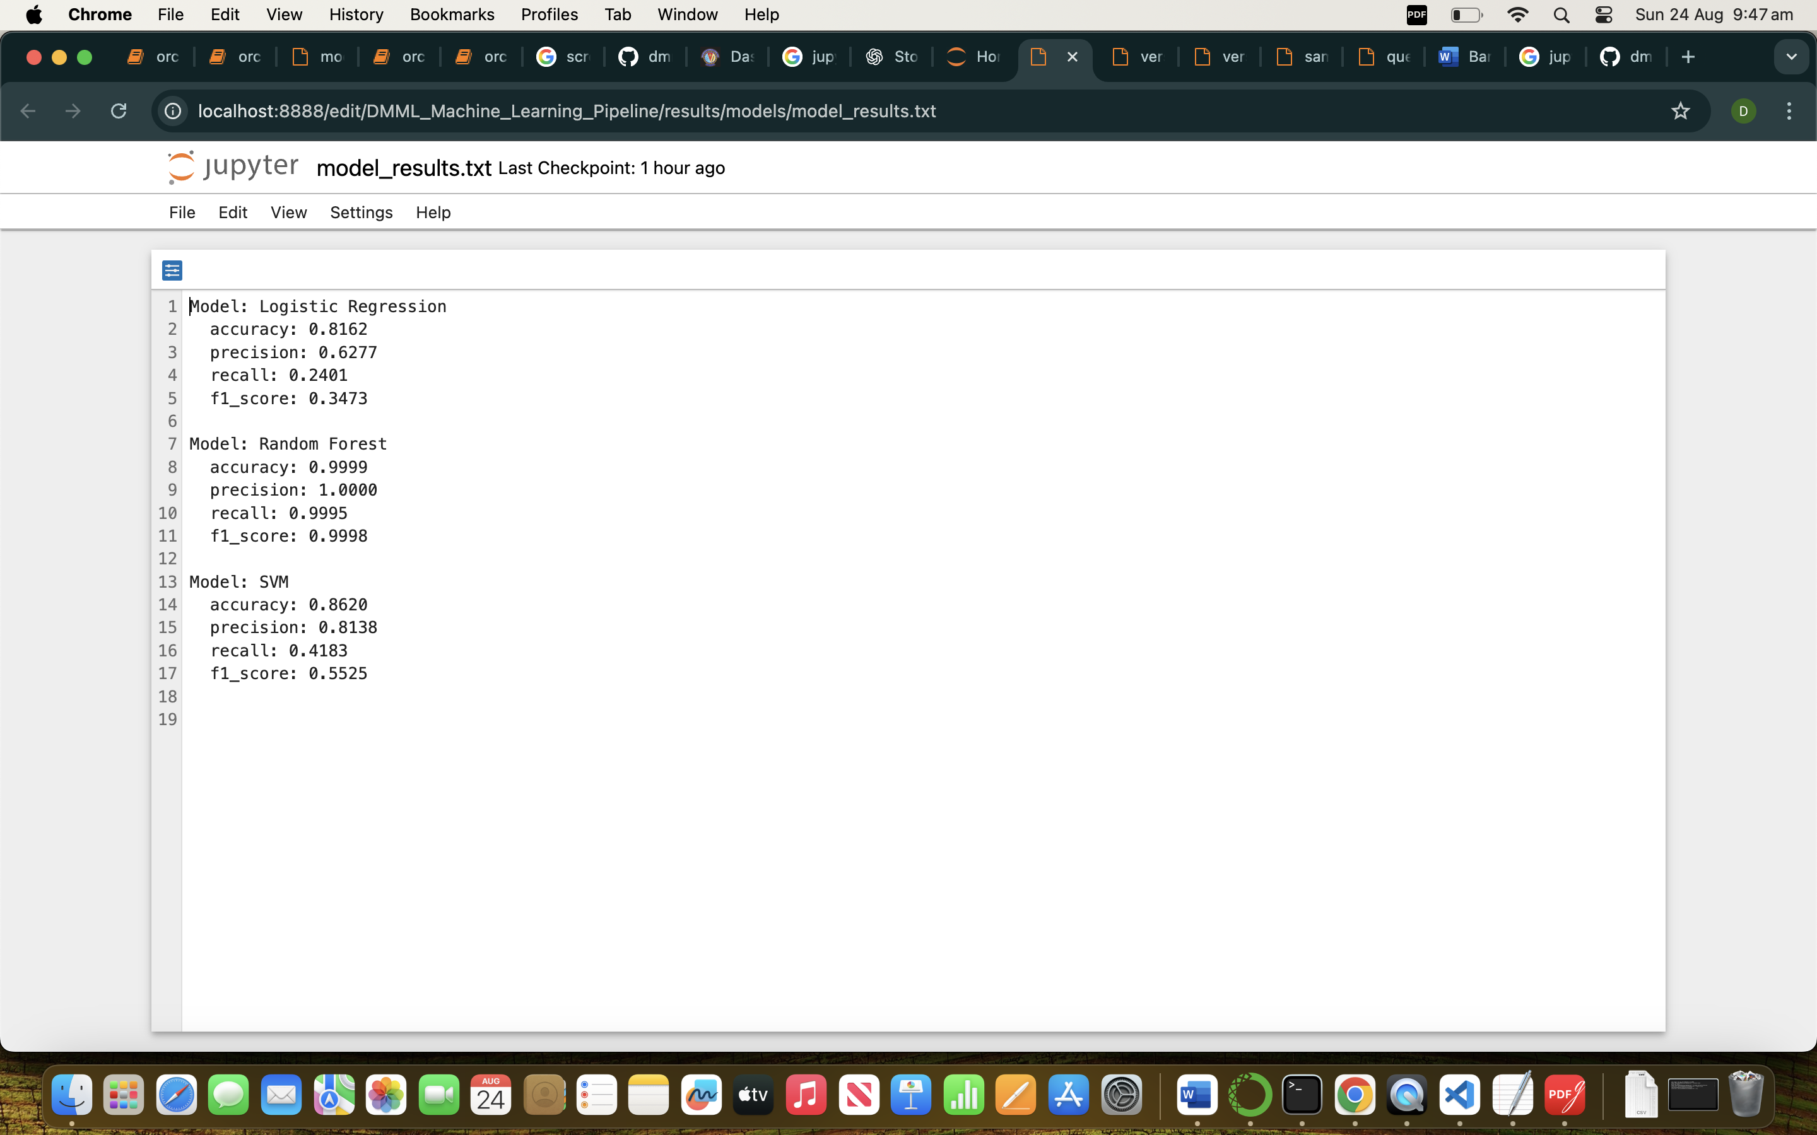

### **Results (based on your logs):**

* + Model: Logistic Regression

accuracy: 0.8162

precision: 0.6277

recall: 0.2401

f1_score: 0.3473

* + Model: Random Forest

accuracy: 0.9999

precision: 1.0000

recall: 0.9995

f1_score: 0.9998

* + Model: SVM

accuracy: 0.8620

precision: 0.8138

recall: 0.4183

f1_score: 0.5525

📌 **Best Model:**

* **Random Forest** was the best-performing model, achieving highest F1 Score
* Selected as **production-ready model**.

## **TASK 10: Pipeline Orchestration**

* Workflow represented using **Graphviz DOT** file.
* Pipeline stages:
  + Data Ingestion
  + Data Storage
  + Data Prepartion
  + Data Transformtion and Storage
  + Feature Engineering
  + Model Training
  + Evaluation
  + Logging & Monitoring

/DMML_Machine_Learning_Pipeline/orchestor.ipynb

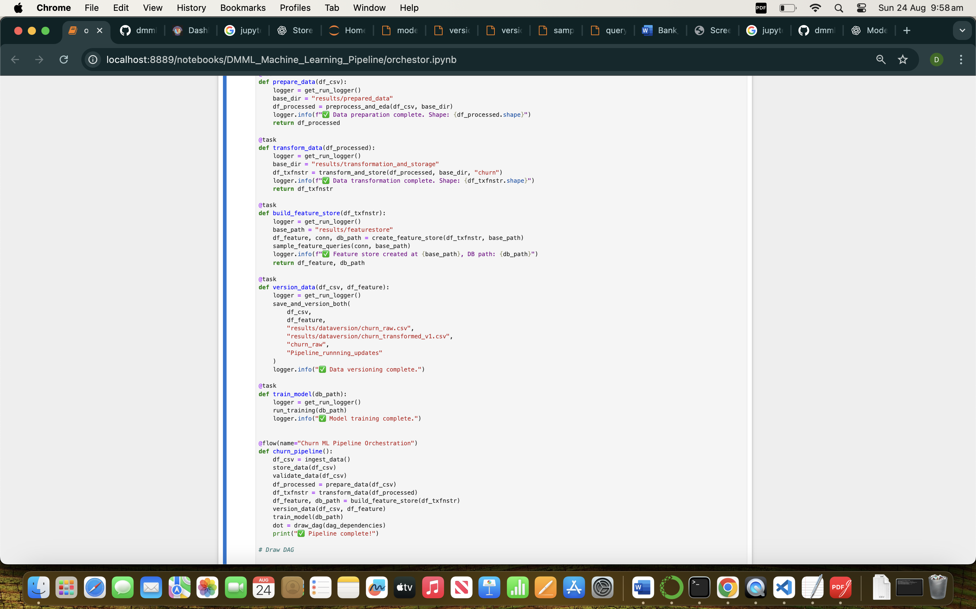

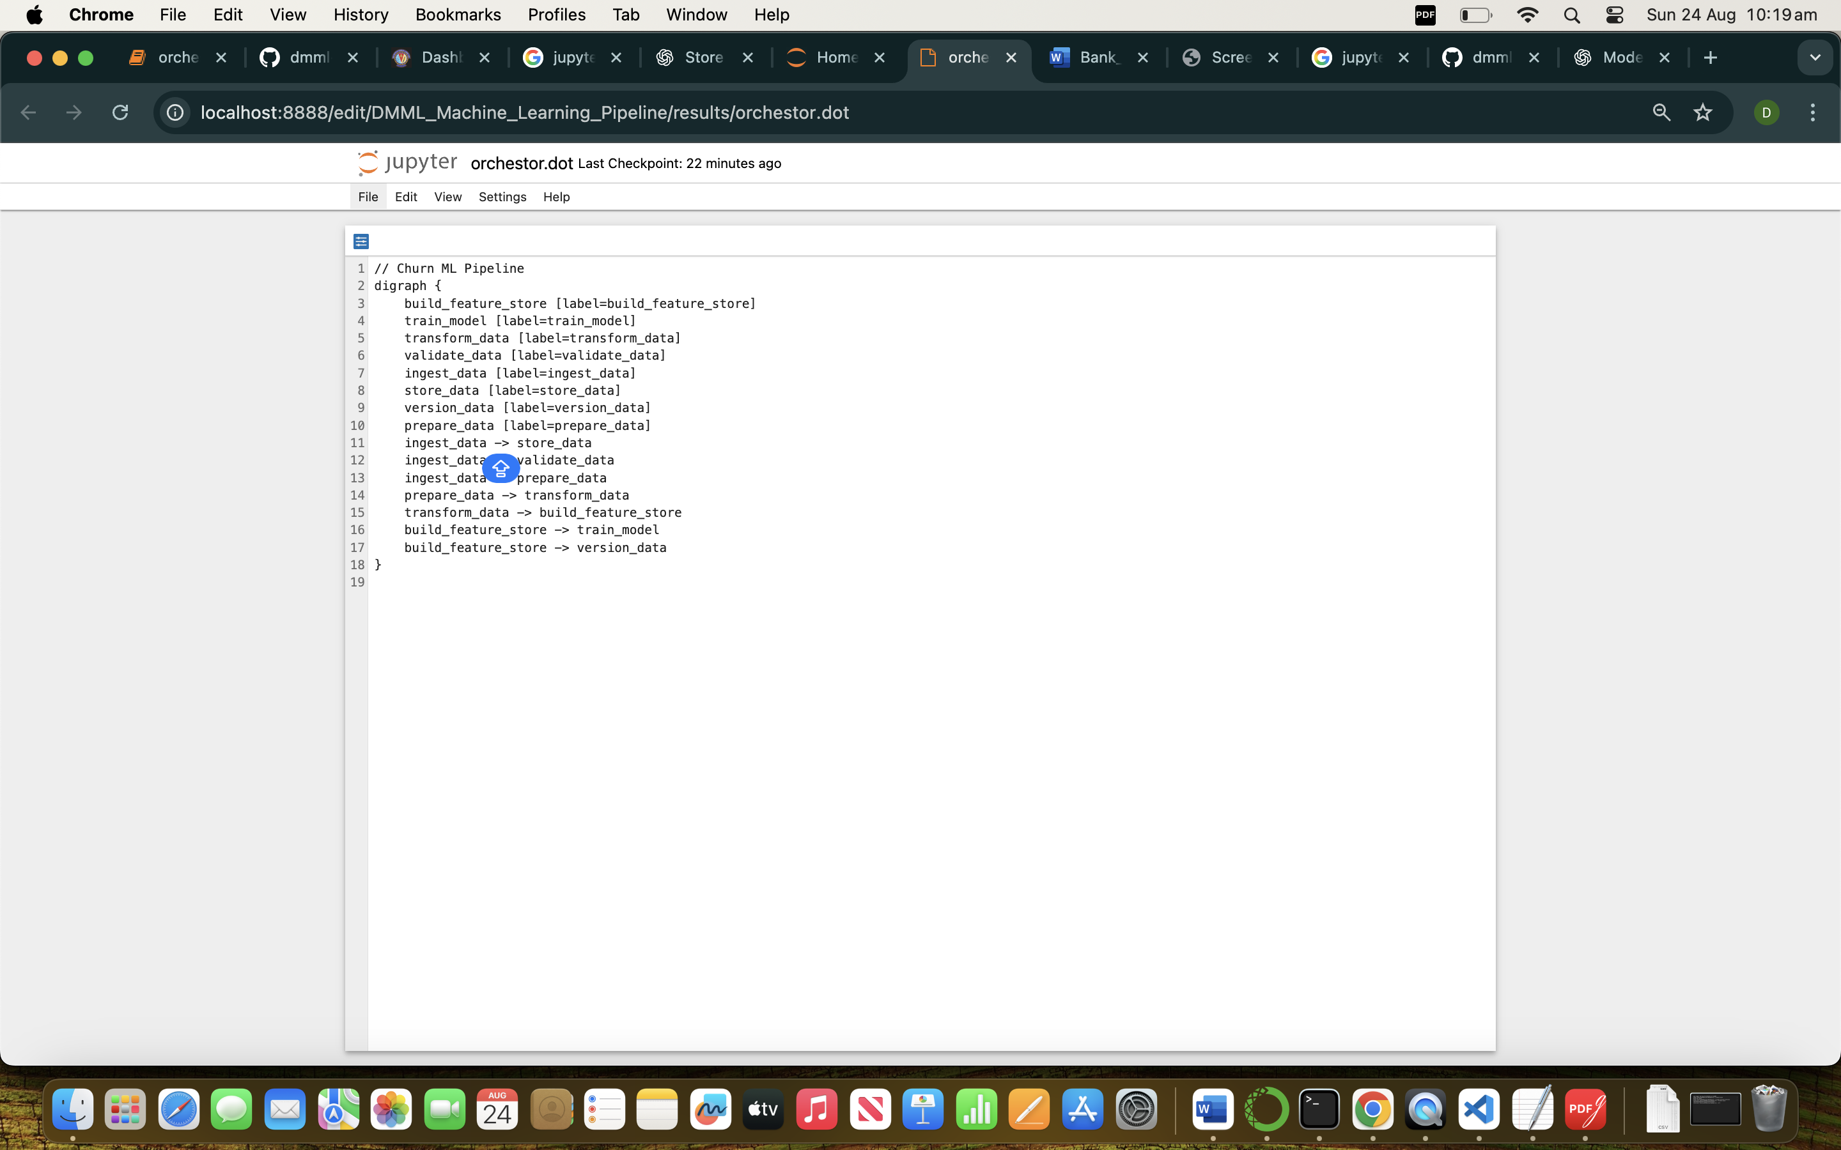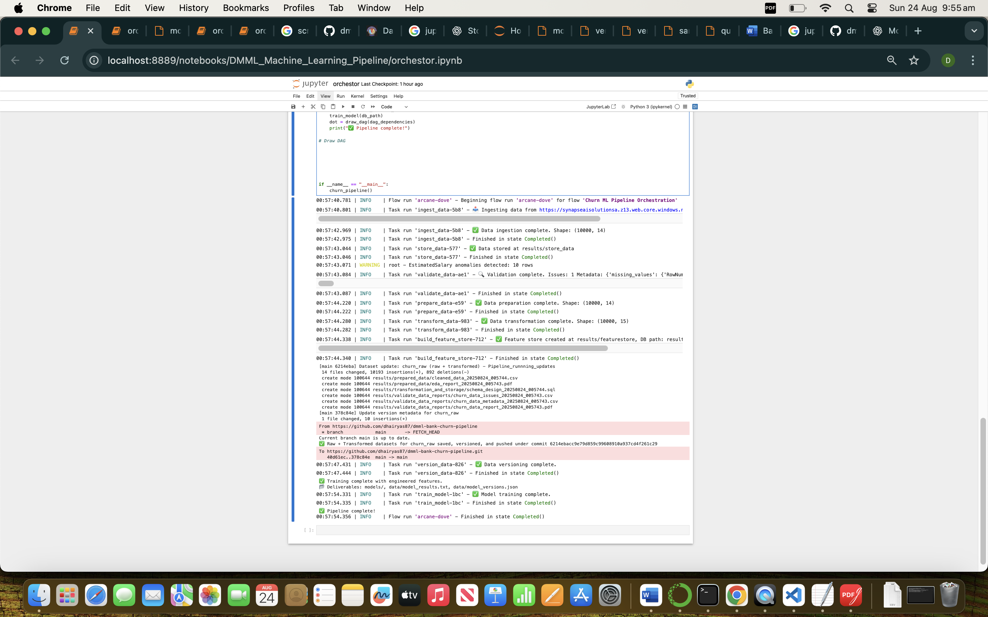

📌 **Benefit:** Fully modular pipeline—each step can be re-run independently and logged.

## **7. Final Insights & Conclusion**

* **Key Drivers of Churn:** Age, Geography, Tenure, Balance, and Products Owned.
* **Actionable Business Insights:**
  + Customers in certain geographies require targeted retention programs.
* **Best Model:** Random Forest chosen for deployment.
* **Next Steps:**
  + Integrate model into customer management system.
  + Monitor performance over time.
  + Retrain periodically with new data.